**Triangles**

# Congruent figures:

Two geometrical figures are called **congruent** if they superpose exactly on each other, that is, they are of the same shape and size.

# Similar figures:

Two figures are **similar**, if they are of the same shape but not necessarily of the same size.

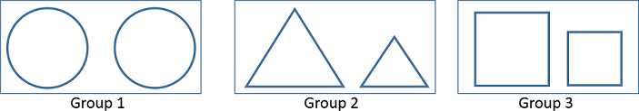

1. All congruent figures are similar but the similar figures need not to be congruent.
2. Two **polygons** having the same number of sides are **similar** if
   1. their corresponding angles are equal and
   2. their corresponding sides are in the same ratio (or proportion).

**Note**: Same ratio of the corresponding sides means the **scale factor** for the polygons.

1. Important facts related to similar figures are:
   1. All circles are similar.
   2. All squares are similar.
   3. All equilateral triangles are similar.
   4. The ratio of any two corresponding sides in two equiangular triangles is always same.
2. Two **triangles are similar** () if
   1. Their corresponding angles are equal.
   2. Their corresponding sides are in same ratio.
3. If the angles in two triangles are:
   1. Different, the triangles are neither similar nor congruent.
   2. Same, the triangles are similar.
   3. Same and the corresponding sides are of the same size, the triangles are congruent.

In the given figure, *A ↔ D*, *B ↔E* and *C ↔ F*, which means triangles ABC and DEF are similar which is represented by Δ *ABC*  Δ *DEF*

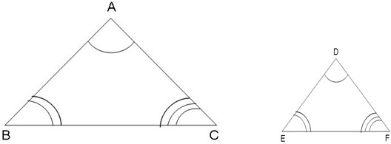

1. If Δ *ABC*  Δ *PQR*, then
   1. *A* = *P*
   2. *B* = *Q*
   3. *C* = *R*
   4. iv.

*AB*  *BC*  *AC*

*PQ QR* P *R*

# Equiangular triangles:

Two triangles are **equiangular** if their corresponding angles are equal. The ratio of any two corresponding sides in such triangles is always the same.

1. **Basic Proportionality Theorem** (Thales Theorem):

If a line is drawn parallel to one side of a triangle to intersect other two sides in distinct points, the other two sides are divided in the same ratio.

# Converse of BPT:

If a line divides any two sides of a triangle in the same ratio then the line is parallel to the third side.

1. A line drawn through the mid-point of one side of a triangle which is parallel to another side bisects the third side. In other words, the line joining the mid-points of any two sides of a triangle is parallel to the third side.

# AAA (Angle-Angle-Angle) similarity criterion:

If in two triangles, corresponding angles are equal, then their corresponding sides are in the same ratio (or proportion) and hence the two triangles are similar.

# AA (Angle-Angle) similarity criterion:

If two angles of a triangle are respectively equal to two angles of another triangle, then by the angle sum property of a triangle their third angles will also be equal.

Thus, **AAA similarity criterion** changes to **AA similarity criterion** which can be stated as follows:

If two angles of one triangle are respectively equal to two angles of other triangle, then the two triangles are similar.

# Converse of *AAA* similarity criterion:

If two triangles are similar, then their corresponding angles are equal.

# SSS (Side-Side-Side) similarity criterion:

If in two triangles, sides of one triangle are proportional to (i.e., in the same ratio of) the sides of the other triangle, then their corresponding angles are equal and hence the two triangles are similar.

# Converse of SSS similarity criterion:

If two triangles are similar, then their corresponding sides are in constant proportion.

# SAS (Side-Angle-Side) similarity criterion:

If one angle of a triangle is equal to one angle of the other triangle and the sides including these angles are proportional, then the two triangles are similar.

# Converse of SAS similarity criterion:

If two triangles are similar, then one of the angles of one triangle is equal to the corresponding angle of the other triangle and the sides including these angles are in constant proportion.

# RHS (Right angle-Hypotenuse-Side) criterion:

If in two right triangles, hypotenuse and one side of one triangle are proportional to the hypotenuse and one side of another triangle, then the two triangles are similar. This criteria is referred as the RHS similarity criterion

# Pythagoras Theorem:

In a right triangle, the square of the hypotenuse is equal to the sum of the squares of the other two sides.

Thus, in triangle *ABC* right angled at *B, AB2 + BC2 = AC2*

# Converse of Pythagoras Theorem:

If in a triangle, square of one side is equal to the sum of the squares of the other two sides, then the angle opposite the first side is a right angle.

1. The **ratio of the areas of two similar triangles** is equal to the square of the ratio of their corresponding sides.

*ar(* *ABC)*  *AB* 2

 *BC* 2

 *CA* 2

Thus, if Δ *ABC*  Δ *PQR*, then

*ar(* *PQR)*   *PQ* 

  *QR* 

  *RP* 

     

Also, the ration of the areas of two similar triangles is equal to the ration of the squares of the corresponding medians.

1. Some important results of similarity are:

* In an equilateral or an isosceles triangle, the altitude divides the base into two equal parts.
* If a perpendicular is drawn from the vertex of the right triangle to the hypotenuse then triangles on both sides of the perpendicular are similar to the whole triangle and to each other.
* The area of an equilateral triangle described on one side of a square is equal to half the area of the equilateral triangle described on one of its diagonal.
* Sum of the squares of the sides of a rhombus is equal to the sum of the squares of its diagonals.
* In an equilateral triangle, three times the square of one side is equal to four times the square of one of its altitudes.